# Collection Runner:

Creating a collection and the use of variables in postman are describes in above. Now we shall look into how to run the created collection containing different requests in a sequence.

Basically collections are a group of API requests that can be run together as a series of requests (one after the other), against a corresponding environment. We can perform the collection run within the postman app using the Collection runner and also from the command line using Postman’s Newman tool (which is discussed later on this blog).

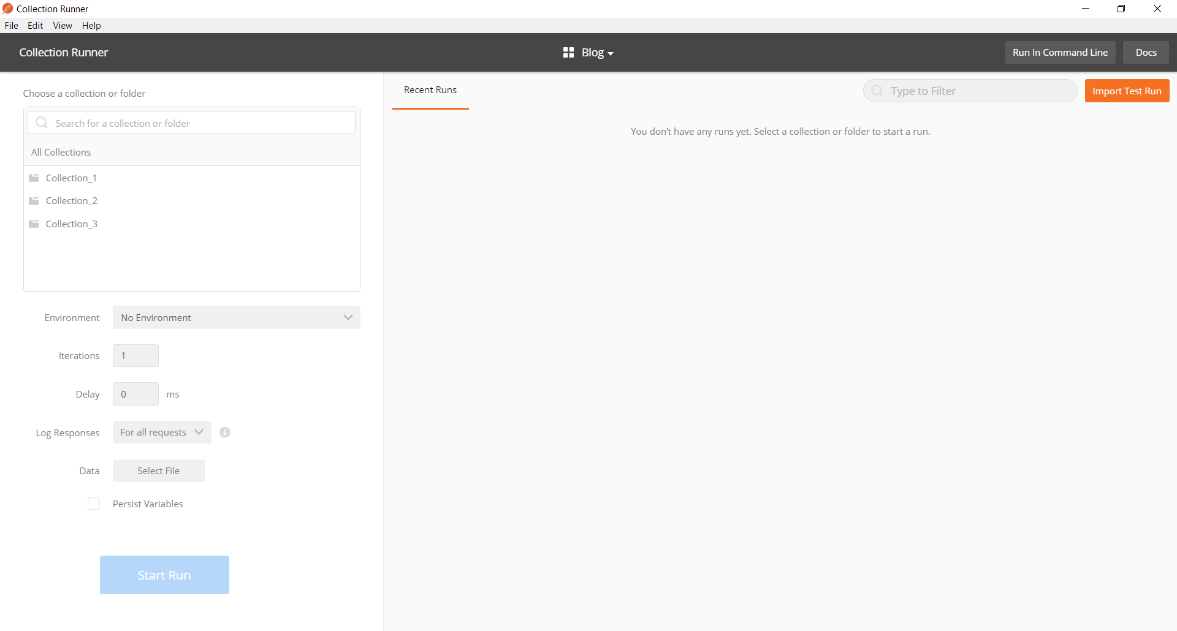

## Starting the Collection Runner

The Collection Runner can be started by clicking on the Runner button in the Tool bar.



Now let’s look over several parameters that you can configure for a collection run.

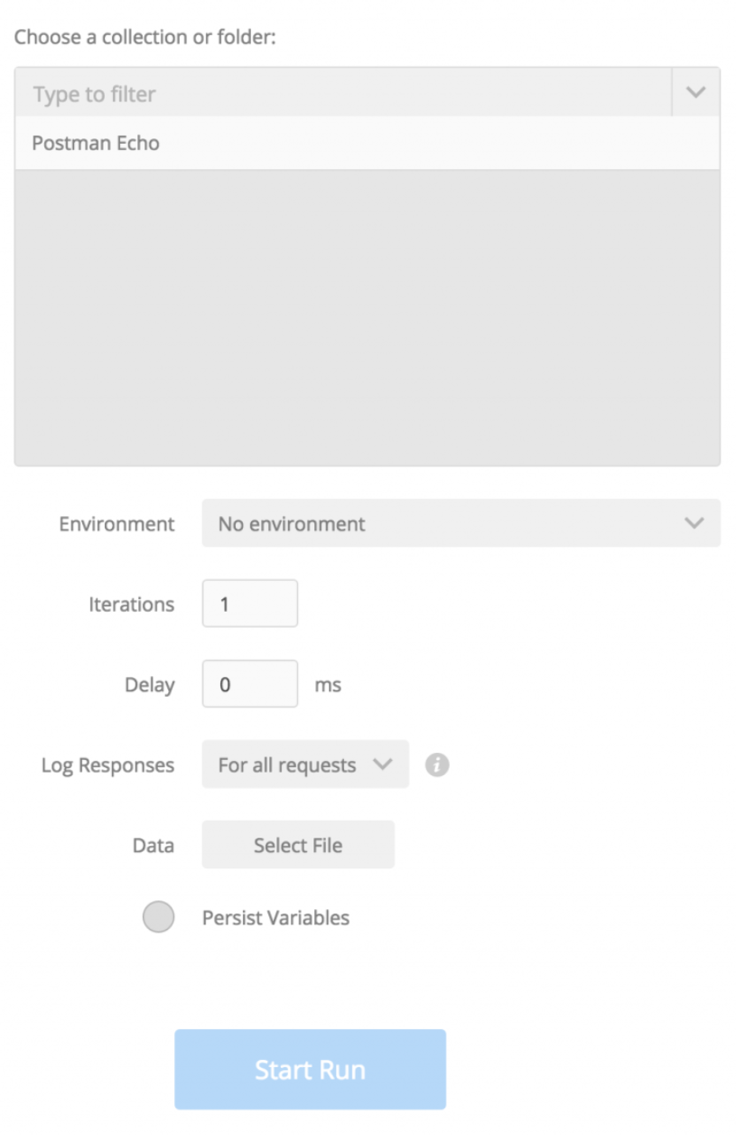

## Choose a Collection or Folder:

In this field we choose the collection or the folder that we want to run. If you choose a collection containing folders, then all the requests in the collection are sent in sequential order in which they are arranged inside the folder.

But, when you select a folder here, only that folder is executed, which means only requests inside the folder are sent.

## Environment:

In this field we choose the environment against which we want to run our collection.

## Iterations:

This is the number of times the whole collection will run. It is used when we have to run the same collection a number of times.

## Delay:

In this field we can set the interval between each request in the collection run if needed.

## Log Responses:

This field is used to limit the response logging when the collection is run. By default all the responses are logged. The options that can be chosen for logging are.

* For all requests: responses for all requests will be logged.
* For failed requests: only responses for requests with at least one failing test will be logged.
* For no requests: no responses will be logged.

## Data:

In this field we supply the data file to be used for the collection run.

## Persist variables:

It is the feature which allows us weather to save or not to save the changes made in the environment variables when the collection is executed in the collection runner. By default, Persist Variables is checked the first time you open the Collection Runner. If you do not want variables to be updated during the run, deselect the Persist Variables checkbox.

Now, once we have filled all the fields according to our need then we can start the Collection Runner by clicking on the Start Run Button.

## Checking and Debugging the Collection Runner Results:

The collection runner also displays the result of the collection run. In this result page we can see the number of passed and failed requests in the total number of iteration.

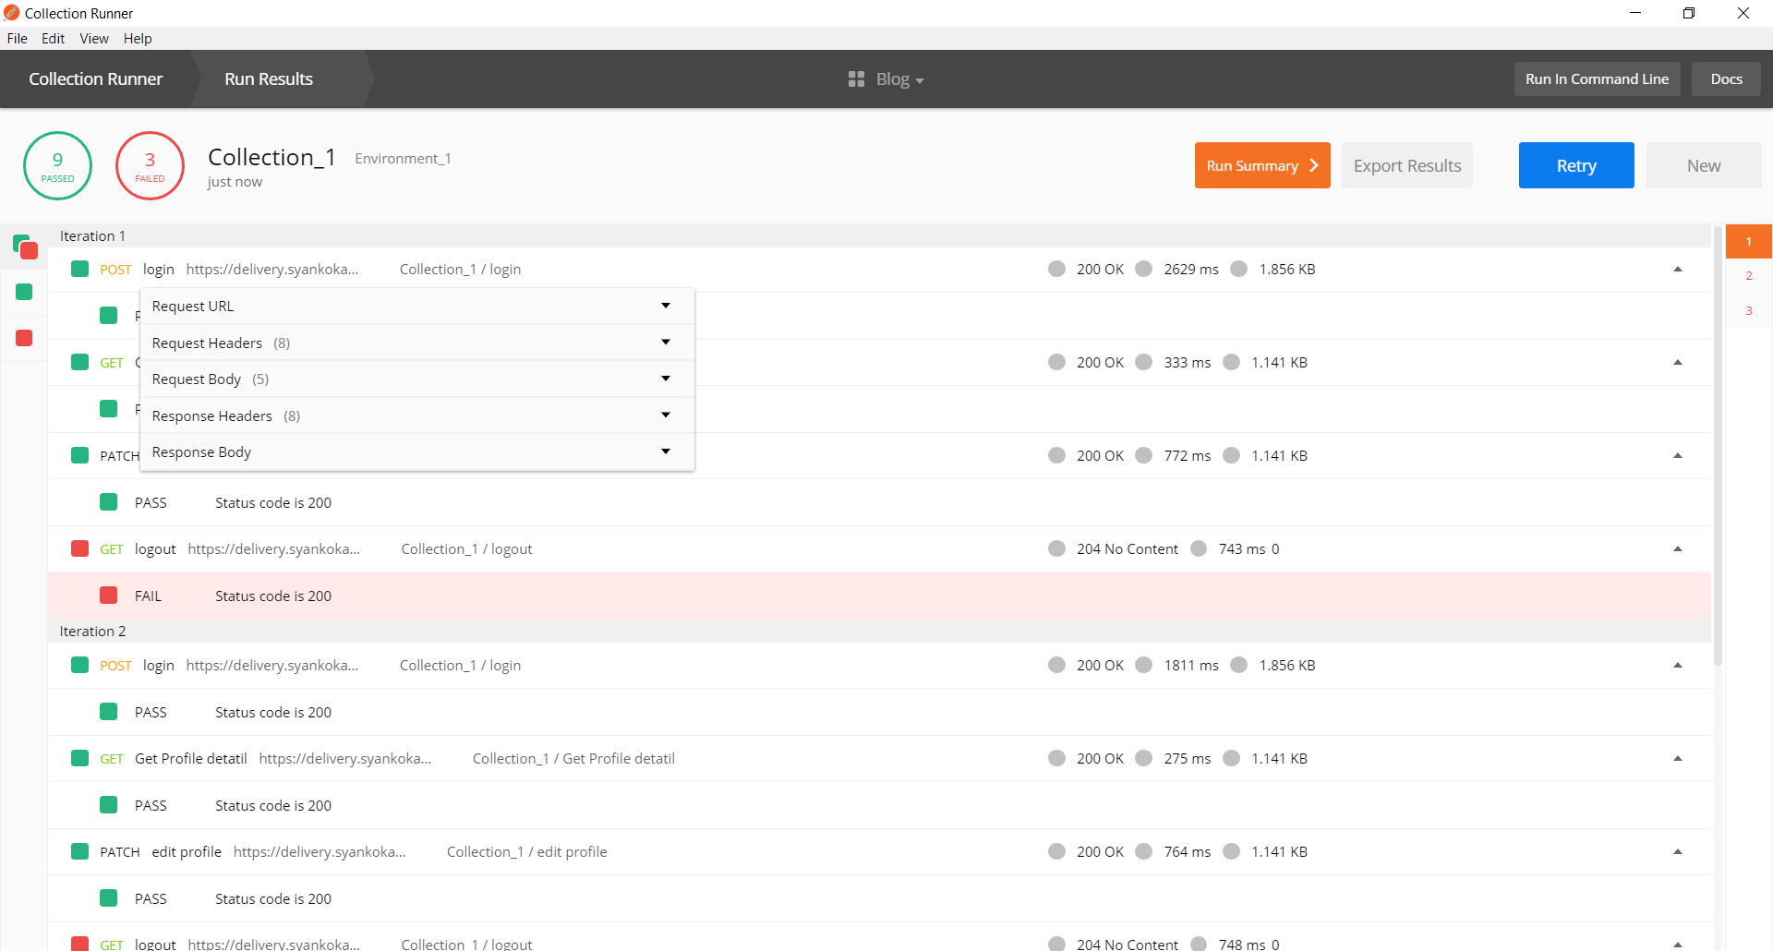

Now things don’t always go as planned and sometimes your collection tests will fail even though you expect them all to pass. When this happens we can debug using the Request and Response Body.

If you click on the request name in your collection run, a dropdown will appear which has the useful information about the request. Information you might need when figuring out what went wrong or why the test failed when it was supposed to pass. By expanding the different fields like Request URL, Request Header, Request Body, Response Headers and Response Body we can see what parameters were sent in the request and what response were generated in the request. Using this information, we solve the problem in the requests in our collection.